User Manual 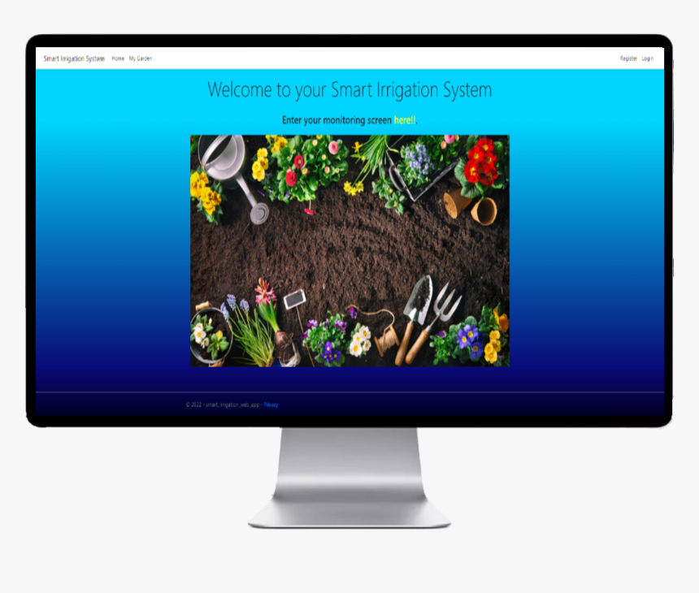

Smart Irrigation System

Vinal Kumar

2022

Contents

01 - Accessing the Smart Irrigation Web Application 2

02 – Registration 3

03 - Login 4

04 – My Garden Dashboard 5

# 01 - Accessing the Smart Irrigation Web Application

Enter the URL <https://smartirrigationfiji.com/> to load the Smart Irrigation Web Application.



You will then be presented with the landing page.

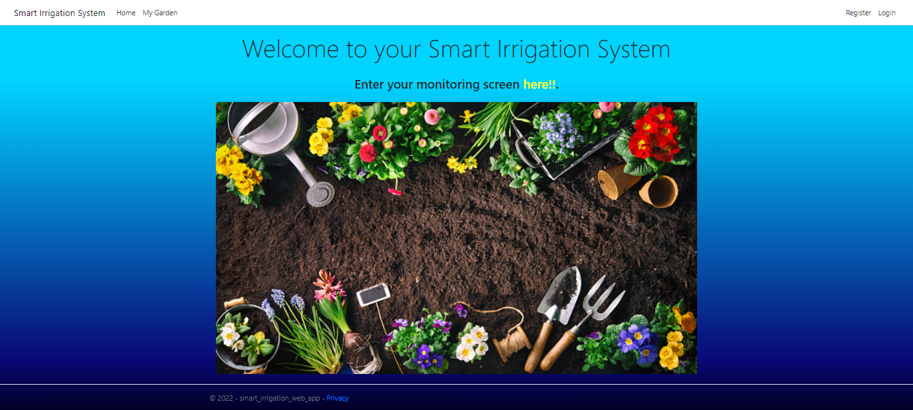

You will see the Home and My Garden page links on the top navigation bar. To access your Garden Dashboard, you must first log in to the system. You can do this by simply clicking on ‘My Garden’ and it will redirect you to the login page or click on ‘Login’ to enter the login screen.

Once you click on either of the options, you will be presented with the below login page.

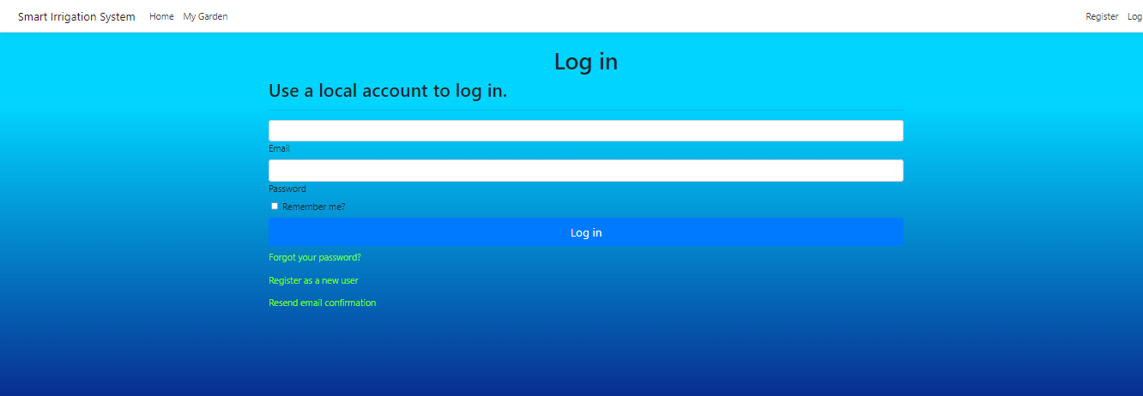

Here you will need to enter your Email and Password to log in. If you are accessing the system for the first time, you will need to Register first.

# 02 – Registration

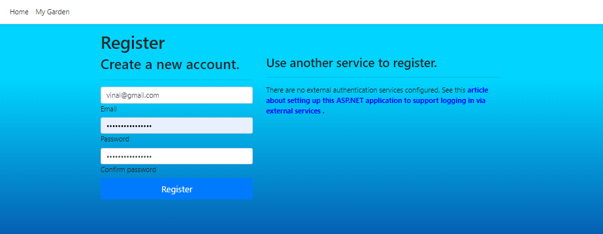

You can Register by clicking on the Register a new user hyperlink from the login screen or click on the Register navigation link which will redirect you to the registration page as shown above. Enter a valid email address and a strong password that you can remember and finally click on the Register button. Once you have successfully completed the registration, you will see a confirmation message as shown below.

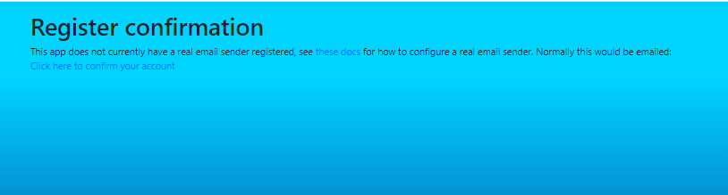

# 03 - Login

Now, going back to the login screen you can enter in your email and password you used and set to log in to your system.

Once logged in, you will see the logout button instead of the login button to logout of the system.



Now you can click on the ‘My Garden’ navigation link to enter your garden dashboard.

# 04 – My Garden Dashboard

Here, you will see your soil moisture levels with the progressive blue bars with their moisture percentages.

1 – The button to manually turn on the water pump.

2 – The button to turn the pump off manually.

3 – The area where you can specify a preferred moisture level threshold. When the moisture level reaches the specified preferred moisture level, the water pump will automatically get triggered releasing a stream of water to the appropriate garden.

END